User Instruction for
Axema VAKA
Brf Snäck
Information to residents about Axema VAKA,
an access control system with booking and door telephony.
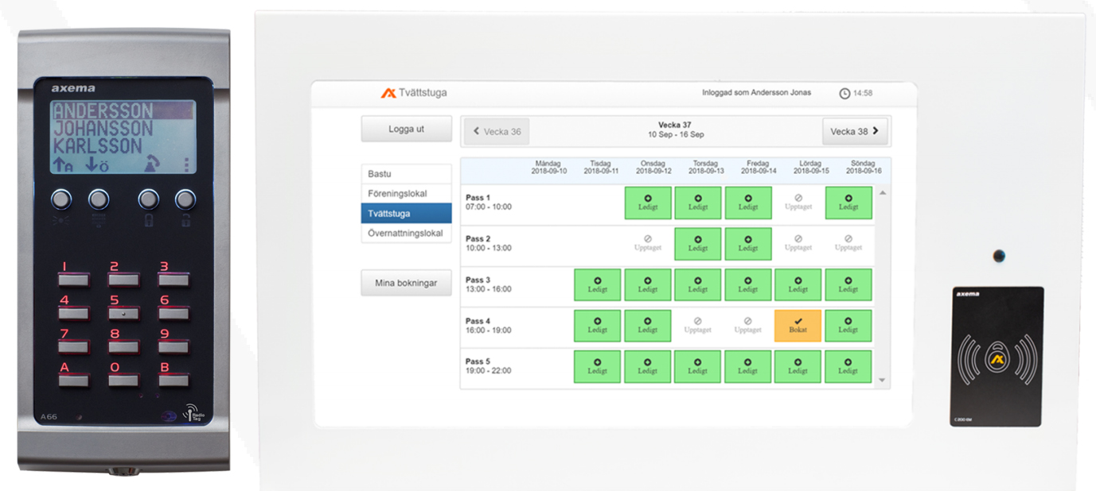

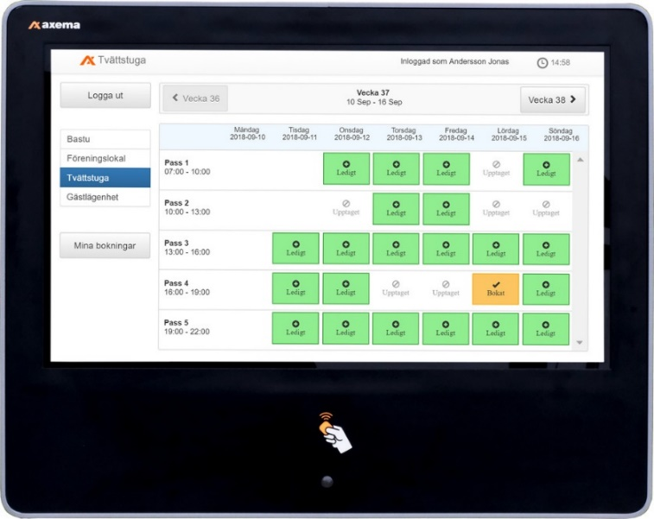
Login to the booking system
Via booking terminal
The booking terminal is located to the right of the notice board on the 1st floor.
When you get close to the screen, it lights up and any information is displayed. Login to the booking system is done by placing the access tag next to the symbol on the booking board, and the booking page opens.
Via online booking
Enter ”bokning.brfsnack.se” in the address field of your favourite browser and you will get to the login screen of the booking system. Fill in the the following fields and press ”Logga in” (log in).
Användare: (=user) Apartment # (three figures)
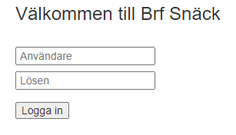
Lösen: (=password) a 4 figure PIN (distributed separately).

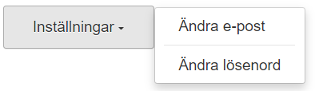
Once you have logged in, you have the possibility to register an email address and a password, which will then also serve as login credentials.
If you have registered an email address, you will receive confirmations and reminders for bookings via email.
Booking instructions
After logging in, the screen shows an overview for the current week and the selected booking item. The week displayed can be changed with the arrows in the upper part of the window and the booking item displayed is selected in the left part of the window.
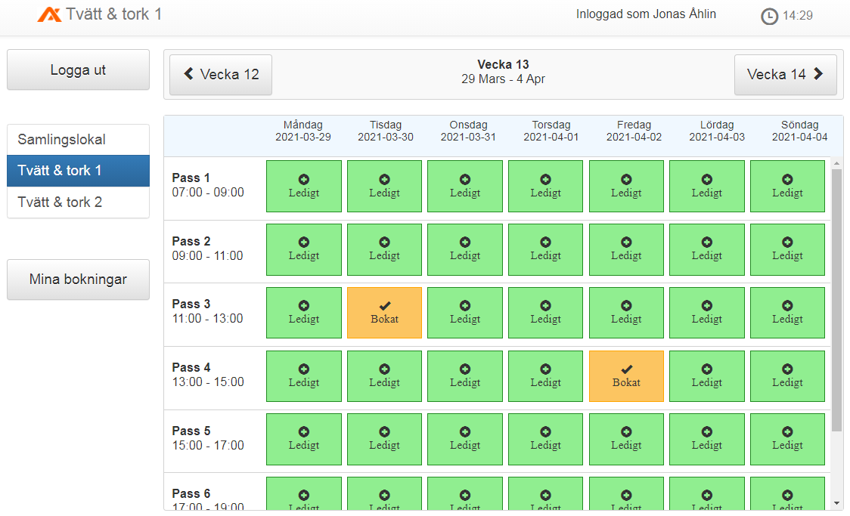
A timeslot can be booked or canceled by clicking on it and then confirming the selection. Under ”Mina bokningar” there is an overview of all your booked slots.
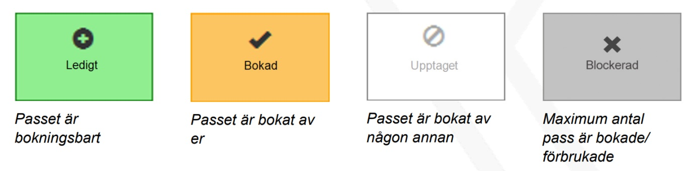
Free Booked by you Booked Blocked
During the booked slot, you can enter the door to the booked object using your access tags / key fobs (all tags belonging to that apartment).
No one else have access to the booked object during this timeslot.
The laundry room
The laundry room
Can be booked 2 times / day and you can have a maximum of 2 active bookings.
When a timeslot is used up, you have the possibility to book a new one.
The passes can be booked continuously 30 days in advance.
Guest apartments 418 och 518
Can be booked per day and you can have a maximum of 8 booked days.
When a day is used up, you have the possibility to book a new one.
The apartments can be booked continuously 180 days in advance.
Timeslots for the apartments are 12:00-11.59 the following day.
You who have booked let your guests into the apartments with your access tag,
then there is a separate access tag in the apartment that can be used during the stay by the guest / guests. This badge is left at the same place at check-out. If it is lost, the booker will be charged SEK 200.
Snäckan (room)
Can be booked per day and you can have a maximum of 3 active bookings.
When one slot is used, there is a possibility to book another one.
Bookings are possible for the next 180 days.
Using the room is for free for members.

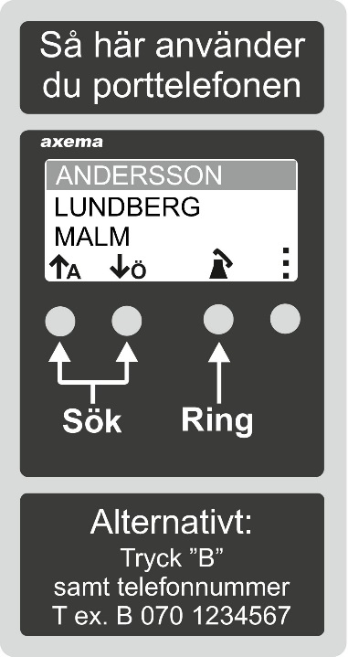
Door telefony
Call using name list
Use the arrows to scroll through the surnames and click the button below the handset to select the last name. Then use the arrows to select first name and click the button below the handset to dial.
This option is active 07:00-22:00.
Call using phone number
Press B, followed by the phone number.
The door phone automatically calls the person if the number is registered in the system.
This option is active 24/7.
Open the door
When the call from the door phone (telephone number: 0498-473318) is accepted, a voice will say "samtal från port". Then the person at the gate can identify him/herself, and if you wish to let them in, you press button 5 in your phone.
Access system – Unlock / open door
Show the access tag to the reader. The system reads the tag and will let you in if you are authorized.

